**App**

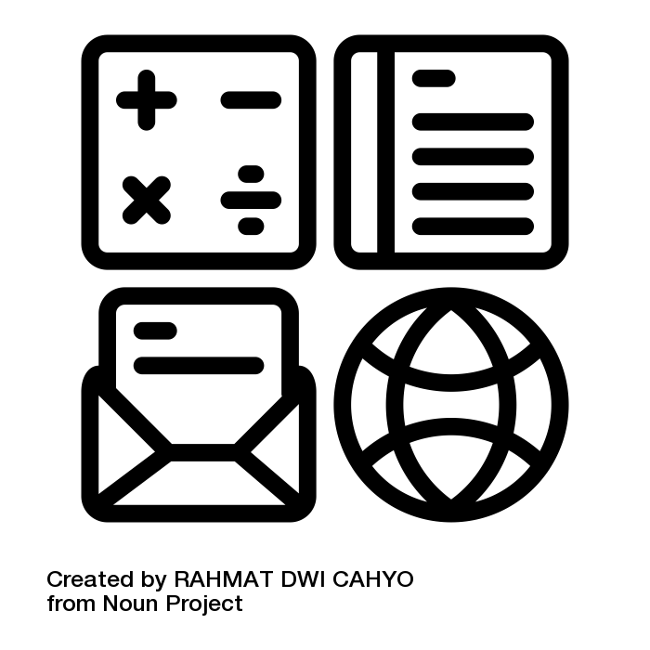

application by RAHMAT DWI CAHYO from <a href="https://thenounproject.com/browse/icons/term/application/" target="_blank" title="application Icons">Noun Project</a>

**Apple ID**

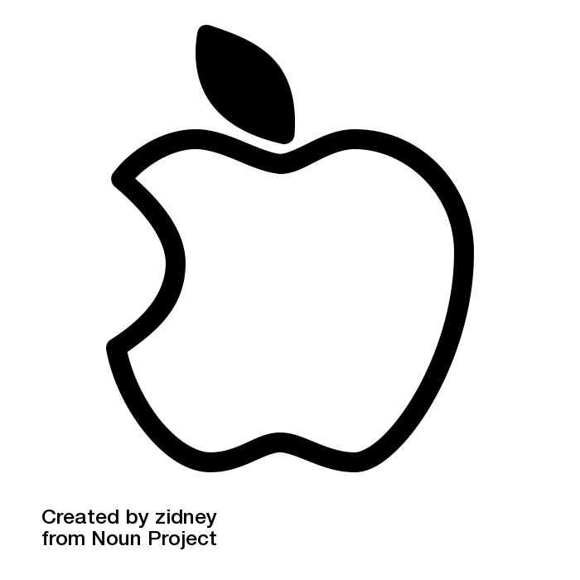

Apple by zidney from <a href="https://thenounproject.com/browse/icons/term/apple/" target="_blank" title="Apple Icons">Noun Project</a>

**Apple Pay**

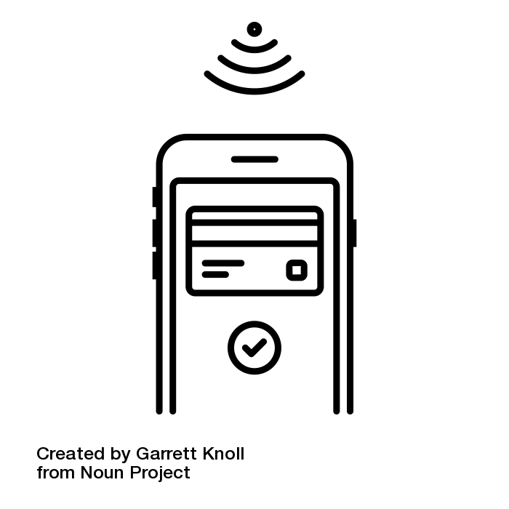

mobile payment by Garrett Knoll from <a href="https://thenounproject.com/browse/icons/term/mobile-payment/" target="_blank" title="mobile payment Icons">Noun Project</a>

**Anti-malware**

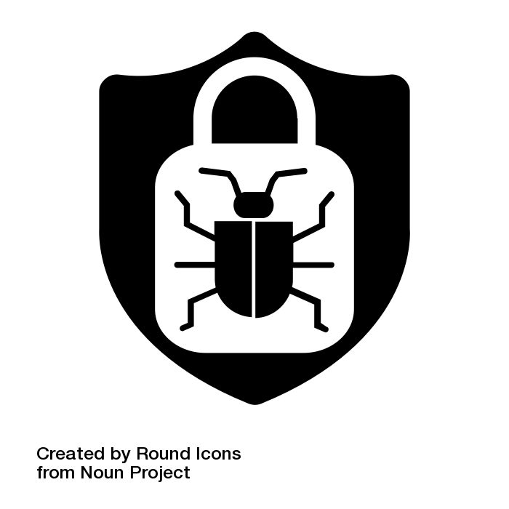

Safe System by Round Icons from <a href=”https://thenounproject.com/browse/icons/term/safe-system/” target=”_blank” title=”Safe System Icons”>Noun Project</a>

**Backup**

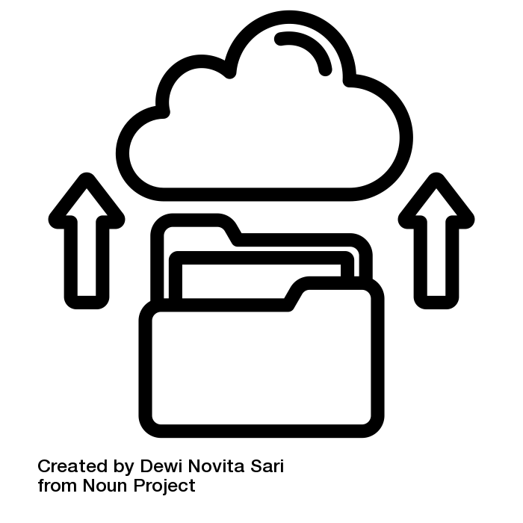

backup by Dewi Novita Sari from <a href="https://thenounproject.com/browse/icons/term/backup/" target="_blank" title="backup Icons">Noun Project</a>

**Battery**

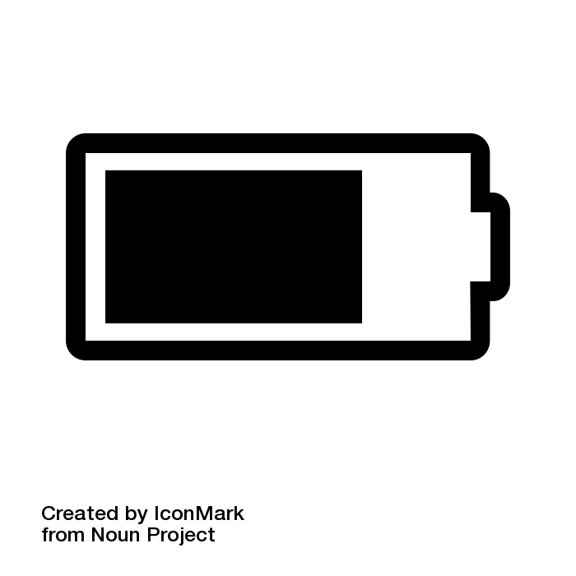

Battery by IconMark from <a href="https://thenounproject.com/browse/icons/term/battery/" target="_blank" title="Battery Icons">Noun Project</a>

**Browser**

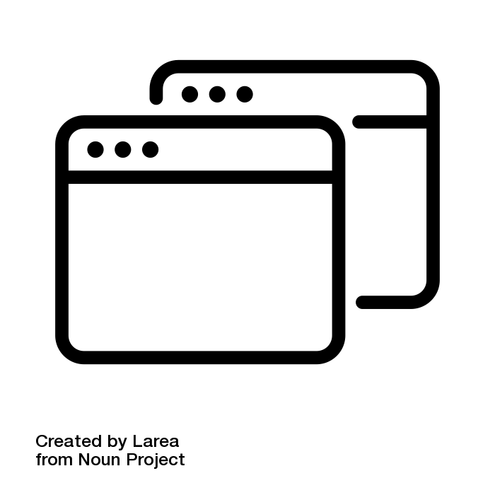

Browser by Larea from <a href="https://thenounproject.com/browse/icons/term/browser/" target="_blank" title="Browser Icons">Noun Project</a>

**Biometrics**

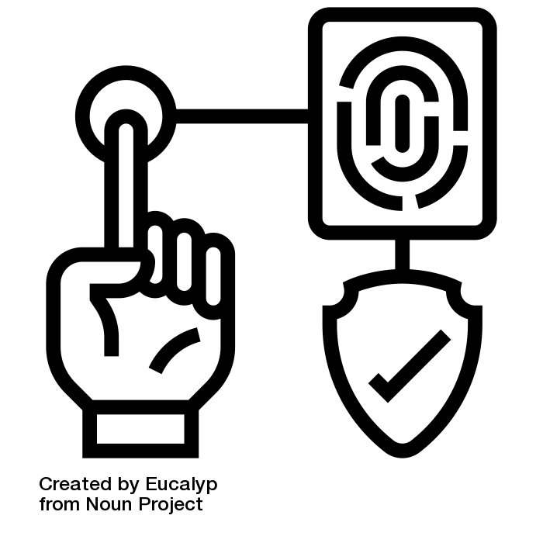

Fingerprint by Eucalyp from <a href="https://thenounproject.com/browse/icons/term/fingerprint/" target="_blank" title="Fingerprint Icons">Noun Project</a>

**Charger**

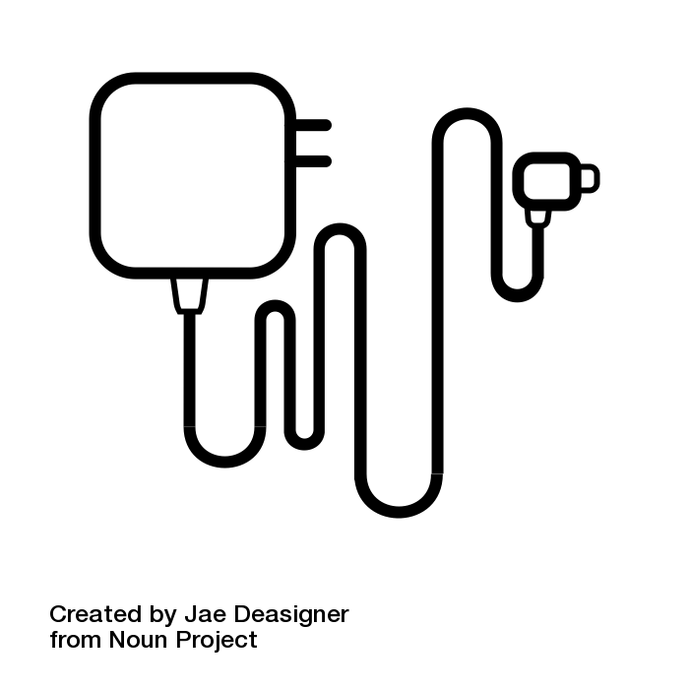

charger by Jae Deasigner from <a href="https://thenounproject.com/browse/icons/term/charger/" target="_blank" title="charger Icons">Noun Project</a>

**Cloud**

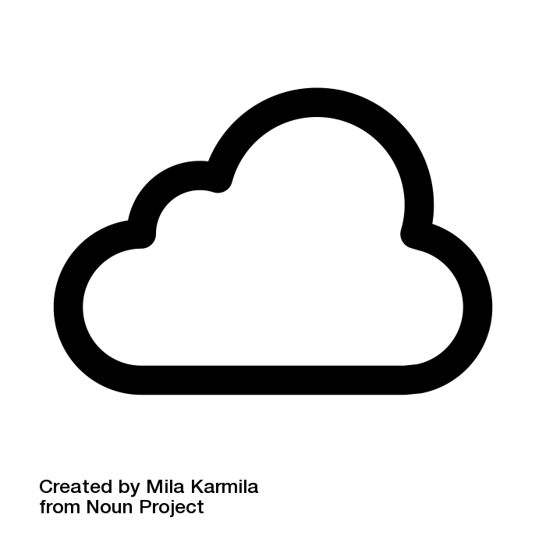

Cloud by Mila Karmila from <a href="https://thenounproject.com/browse/icons/term/cloud/" target="_blank" title="Cloud Icons">Noun Project</a>

**Credible**

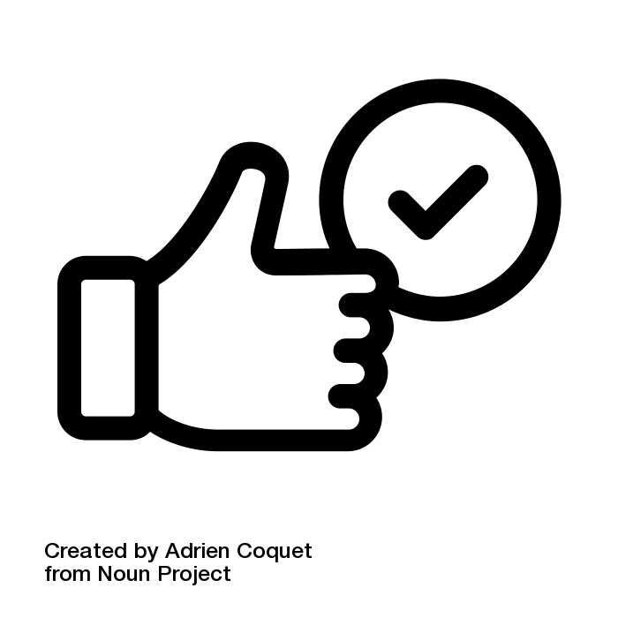

safe by Adrien Coquet from <a href="https://thenounproject.com/browse/icons/term/safe/" target="_blank" title="safe Icons">Noun Project</a>

**Customize Settings**

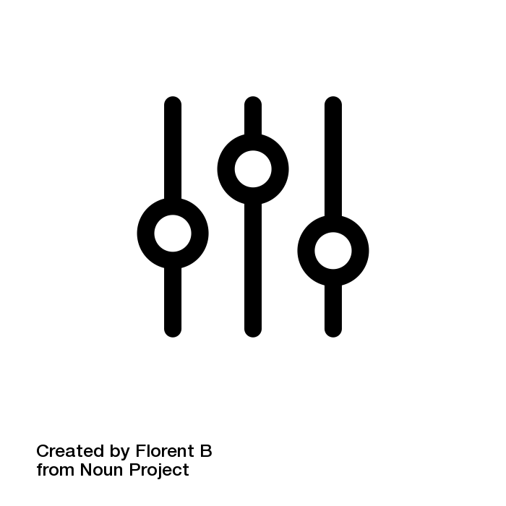

customise by Florent B from <a href="https://thenounproject.com/browse/icons/term/customise/" target="_blank" title="customise Icons">Noun Project</a>

**Cyber**

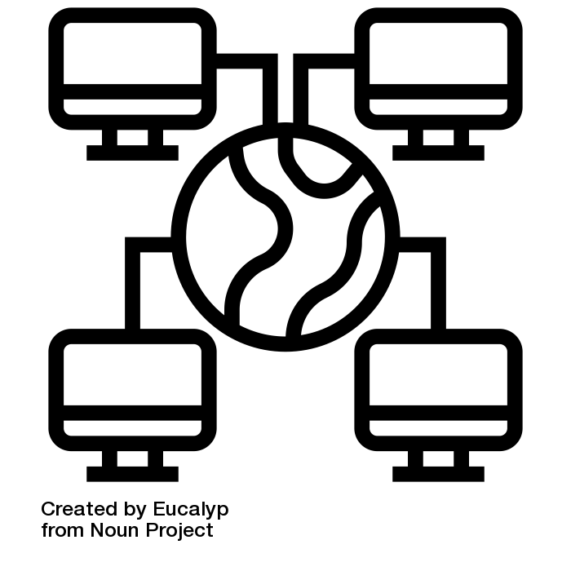

cyber by Eucalyp from <a href="https://thenounproject.com/browse/icons/term/cyber/" target="_blank" title="cyber Icons">Noun Project</a>

**Cybersecurity**

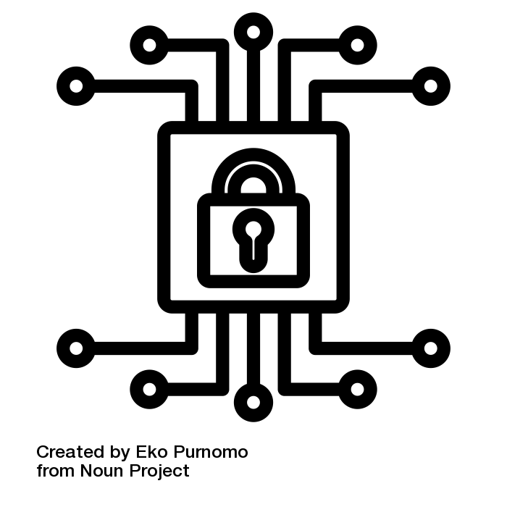

cyber security by Eko Purnomo from <a href="https://thenounproject.com/browse/icons/term/cyber-security/" target="_blank" title="cyber security Icons">Noun Project</a>

**Cyberspace**

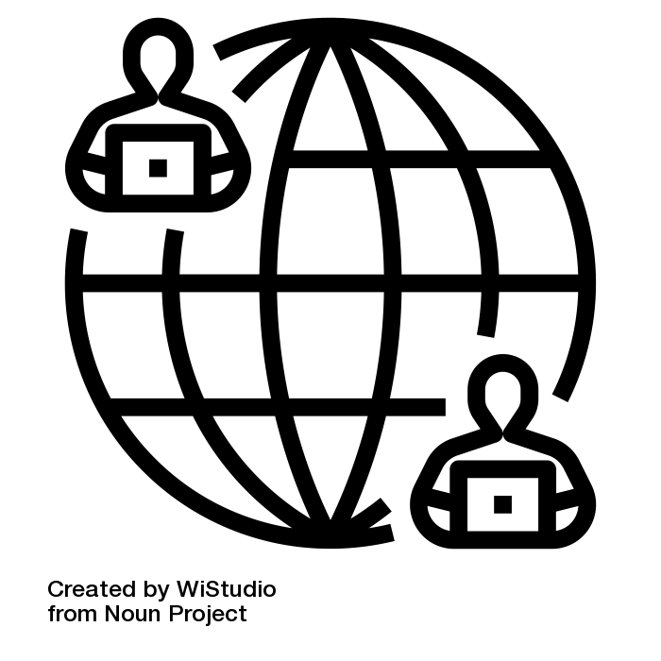

globalization by WiStudio from <a href="https://thenounproject.com/browse/icons/term/globalization/" target="_blank" title="globalization Icons">Noun Project</a>

**Cyberbullying**

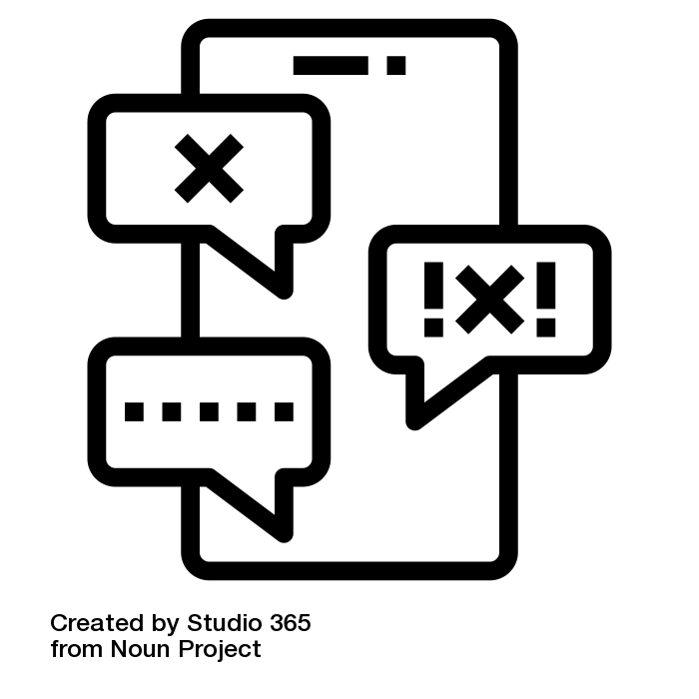

cyberbullying by Studio 365 from <a href="https://thenounproject.com/browse/icons/term/cyberbullying/" target="_blank" title="cyberbullying Icons">Noun Project</a>

**Digital Literacy**

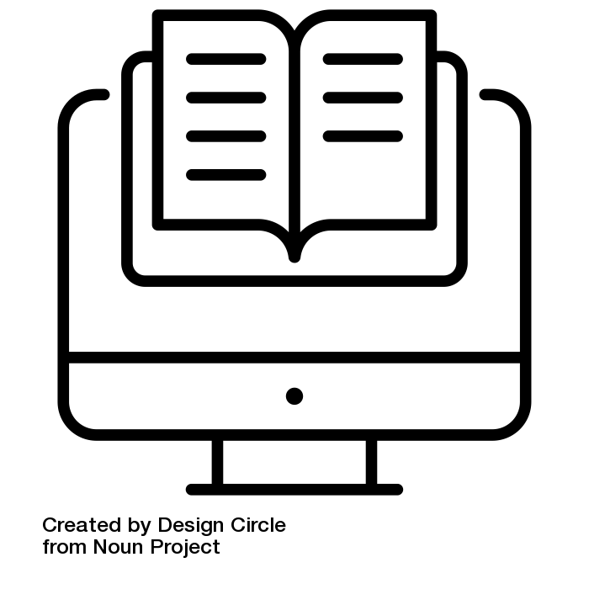

digital literacy by Design Circle from <a href="https://thenounproject.com/browse/icons/term/digital-literacy/" target="_blank" title="digital literacy Icons">Noun Project</a>

**Digital**

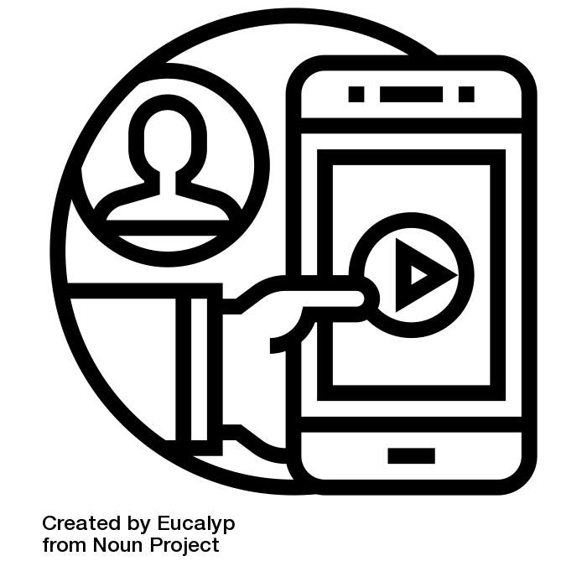

digital by Eucalyp from <a href="https://thenounproject.com/browse/icons/term/digital/" target="_blank" title="digital Icons">Noun Project</a>

**Digital Footprint**

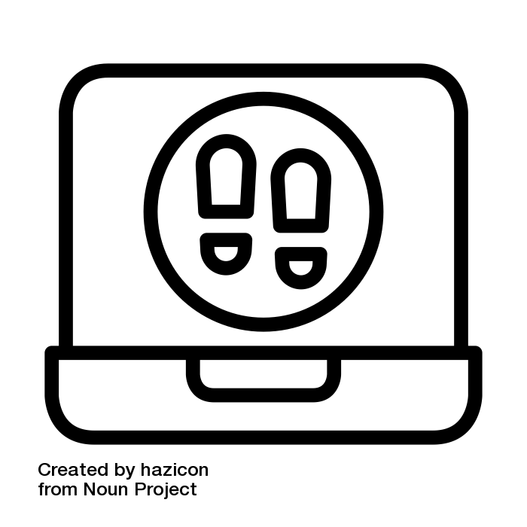

digital footprint by hazicon from <a href="https://thenounproject.com/browse/icons/term/digital-footprint/" target="_blank" title="digital footprint Icons">Noun Project</a>

**Digital Literacy Coach**

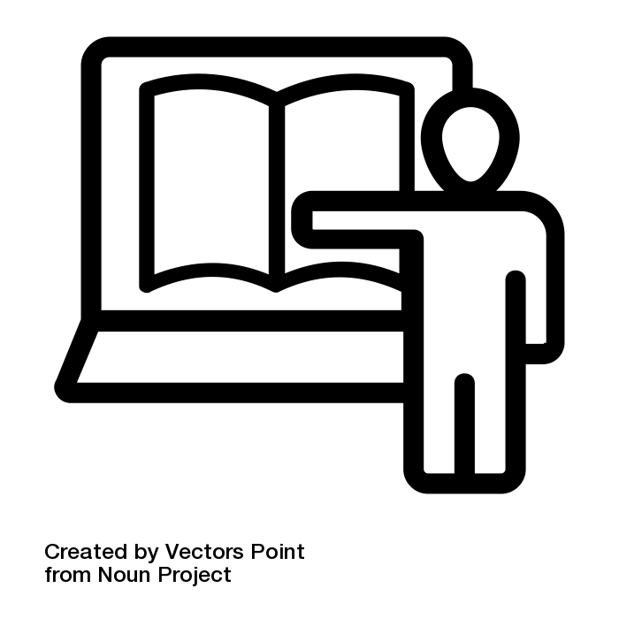

Online teacher by Vectors Point from <a href="https://thenounproject.com/browse/icons/term/online-teacher/" target="_blank" title="Online teacher Icons">Noun Project</a>

**Download**

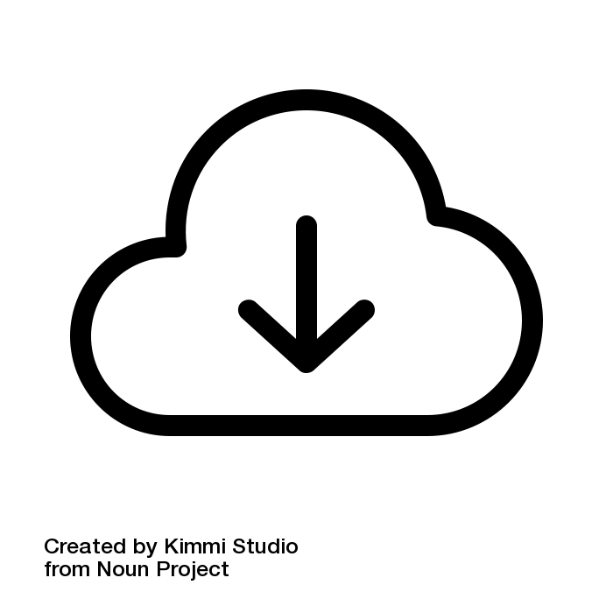

Download by Kimmi Studio from <a href="https://thenounproject.com/browse/icons/term/download/" target="_blank" title="Download Icons">Noun Project</a>

**Dignity of Risk**

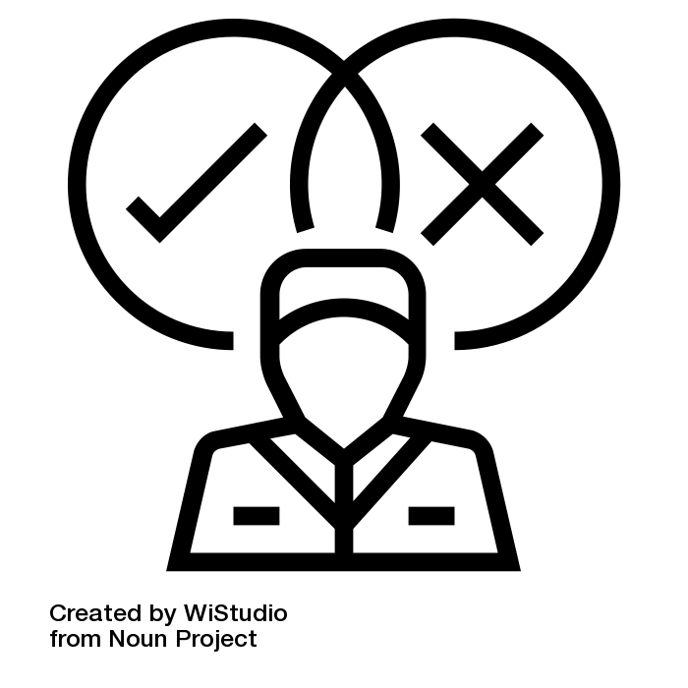

decision by WiStudio from <a href="https://thenounproject.com/browse/icons/term/decision/" target="_blank" title="decision Icons">Noun Project</a>

**Elective**

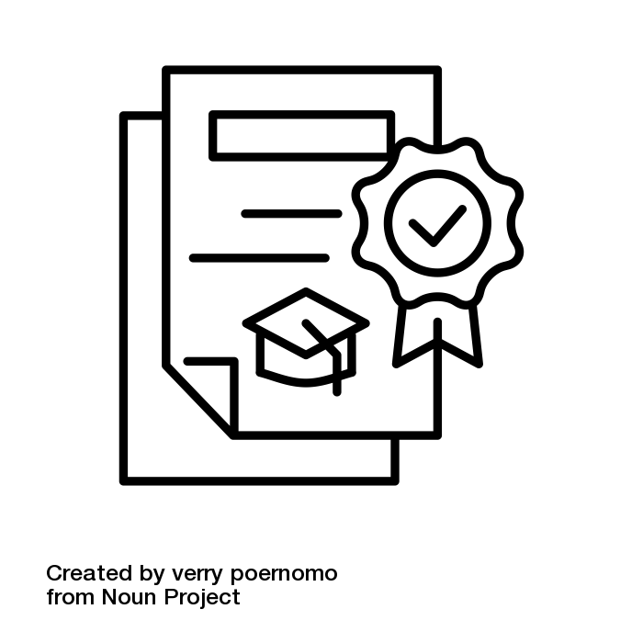

college diploma by verry poernomo from <a href="https://thenounproject.com/browse/icons/term/college-diploma/" target="_blank" title="college diploma Icons">Noun Project</a>

**Email**

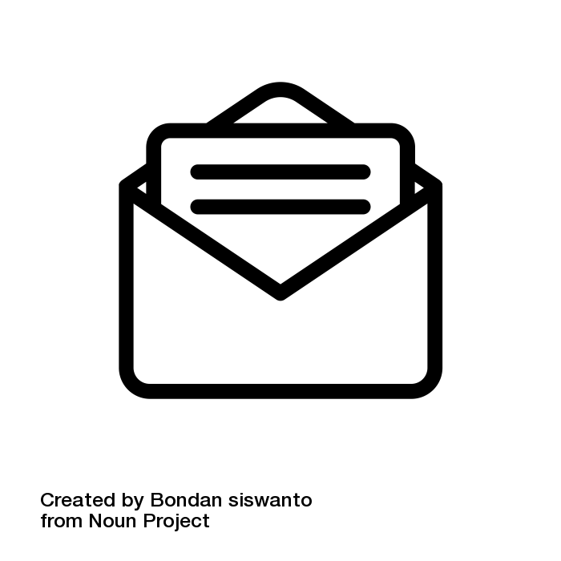

Email by Bondan siswanto from <a href="https://thenounproject.com/browse/icons/term/email/" target="_blank" title="Email Icons">Noun Project</a>

**Encryption**

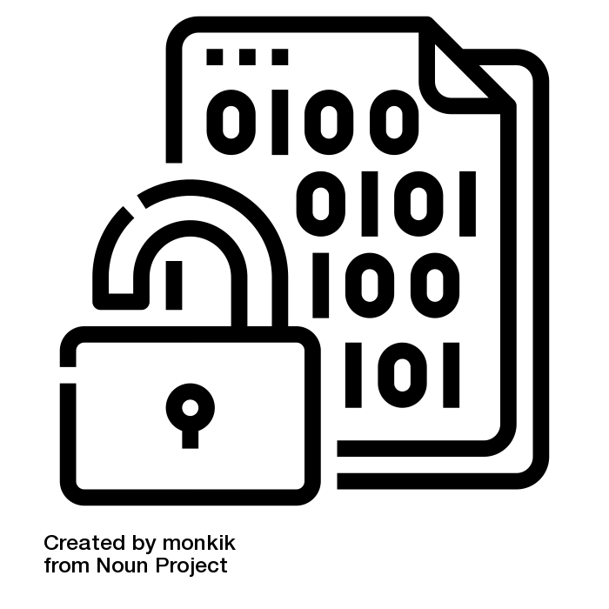

encryption by monkik from <a href="https://thenounproject.com/browse/icons/term/encryption/" target="_blank" title="encryption Icons">Noun Project</a>

**Error Message**

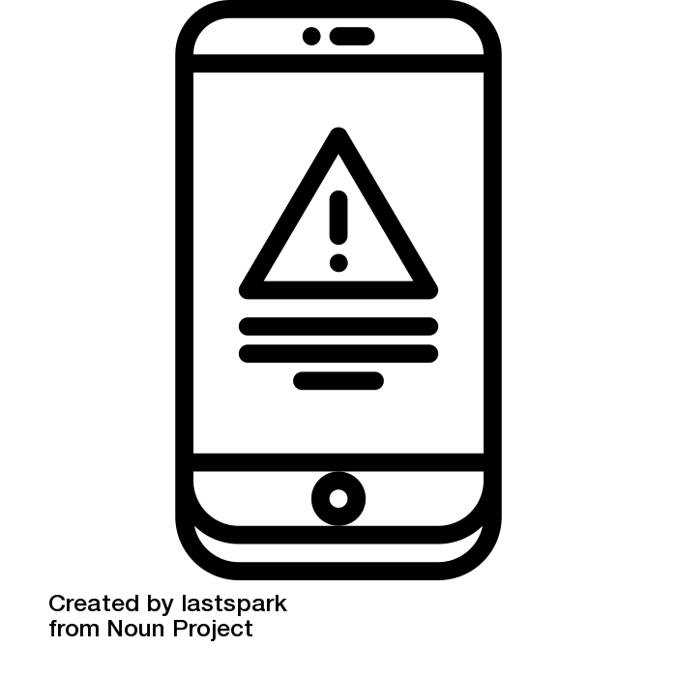

Error by lastspark from <a href="https://thenounproject.com/browse/icons/term/error/" target="_blank" title="Error Icons">Noun Project</a>

**Etiquette**

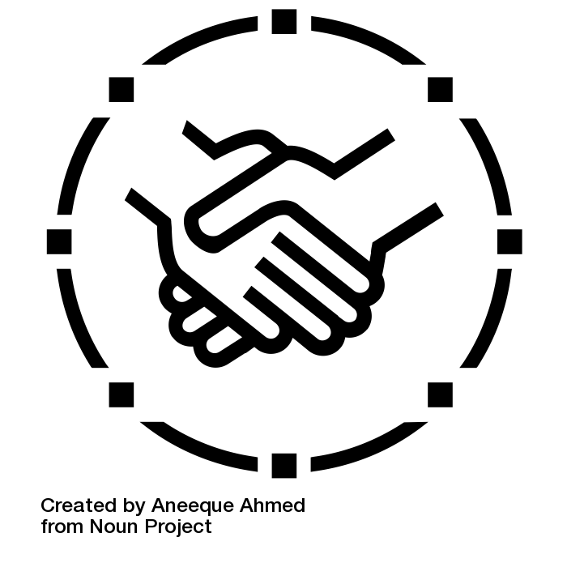

Handshake by Aneeque Ahmed from <a href="https://thenounproject.com/browse/icons/term/handshake/" target="_blank" title="Handshake Icons">Noun Project</a>

**Flame War**

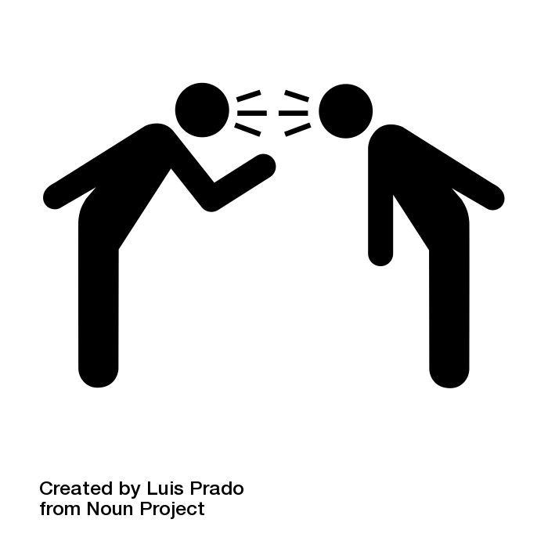

verbal fight by Luis Prado from <a href="https://thenounproject.com/browse/icons/term/verbal-fight/" target="_blank" title="verbal fight Icons">Noun Project</a>

**Find my Device**

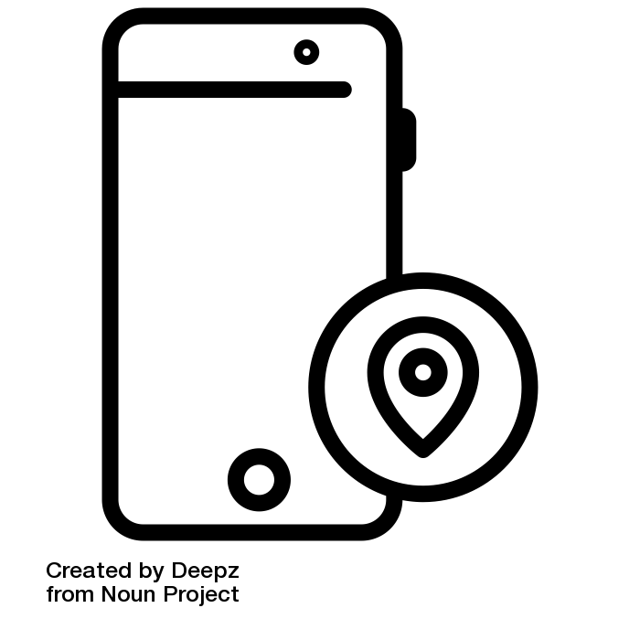

mobile location by Deepz from <a href="https://thenounproject.com/browse/icons/term/mobile-location/" target="_blank" title="mobile location Icons">Noun Project</a>

**Firewall**

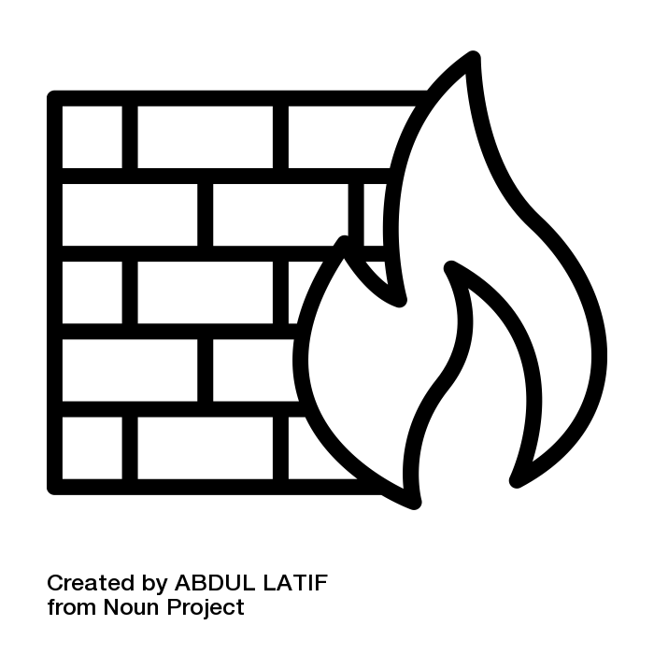

firewall by ABDUL LATIF from <a href="https://thenounproject.com/browse/icons/term/firewall/" target="_blank" title="firewall Icons">Noun Project</a>

**Gesture**

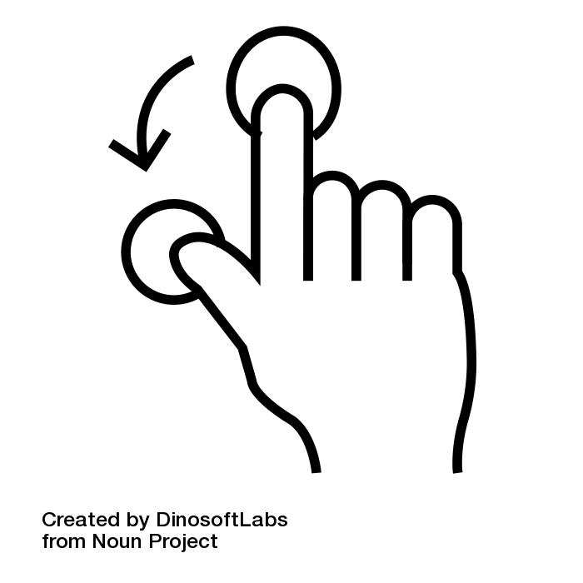

Gesture by DinosoftLabs from <a href="https://thenounproject.com/browse/icons/term/gesture/" target="_blank" title="Gesture Icons">Noun Project</a>

**GHz (Gigahertz)**

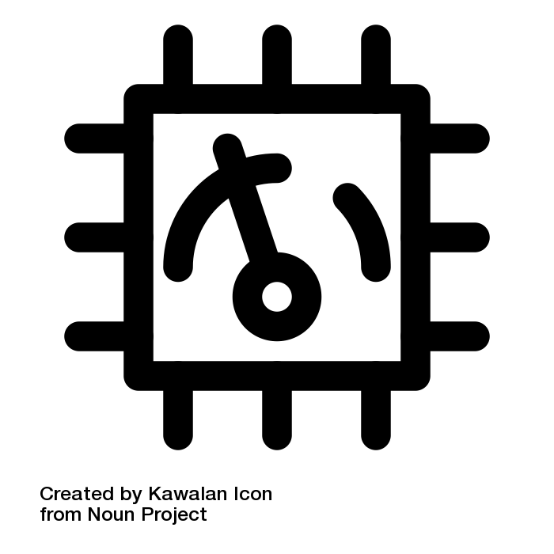

processor speed by Kawalan Icon from <a href="https://thenounproject.com/browse/icons/term/processor-speed/" target="_blank" title="processor speed Icons">Noun Project</a>

**GPS**

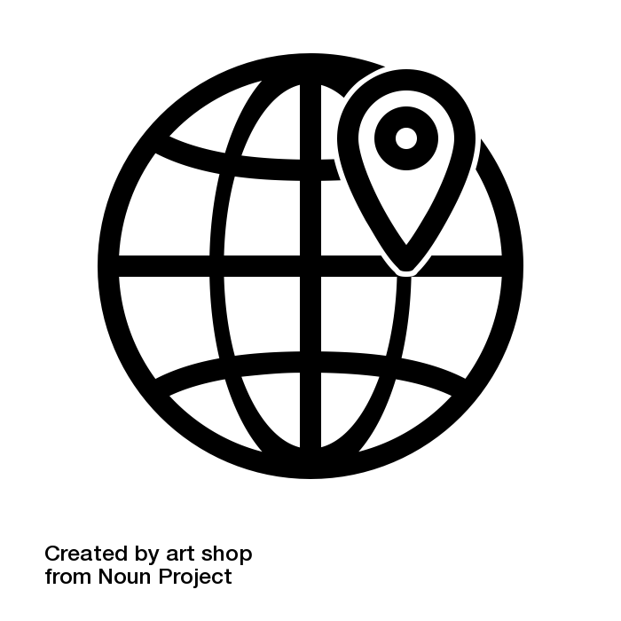

GPS by art shop from <a href="https://thenounproject.com/browse/icons/term/gps/" target="_blank" title="GPS Icons">Noun Project</a>

**Hardware**

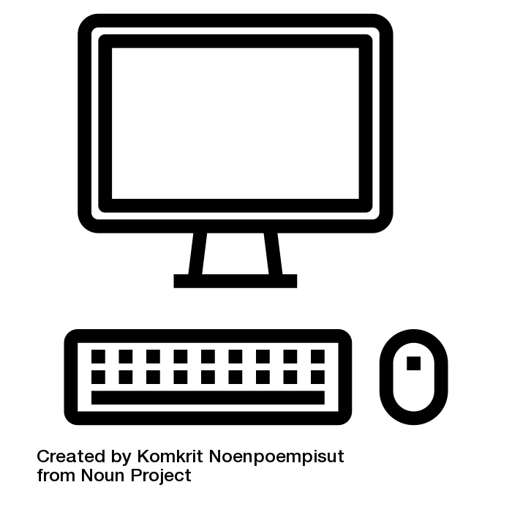

computer hardware by Komkrit Noenpoempisut from <a href="https://thenounproject.com/browse/icons/term/computer-hardware/" target="_blank" title="computer hardware Icons">Noun Project</a>

**Hot Spot**

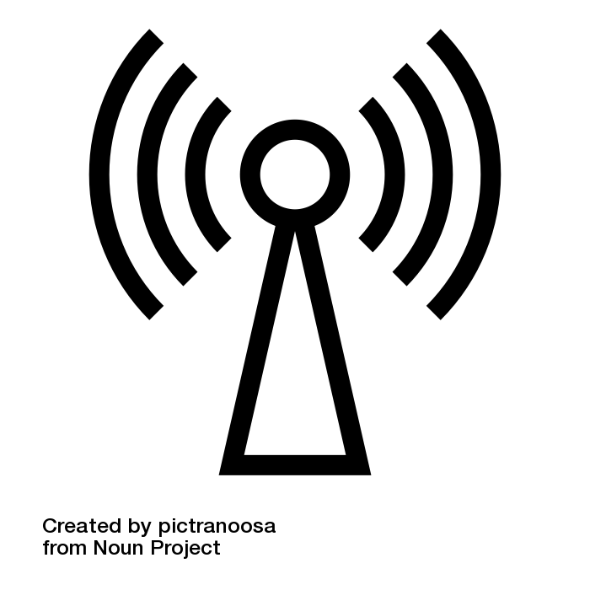

hot spot by pictranoosa from <a href="https://thenounproject.com/browse/icons/term/hot-spot/" target="_blank" title="hot spot Icons">Noun Project</a>

**Information Gathering**

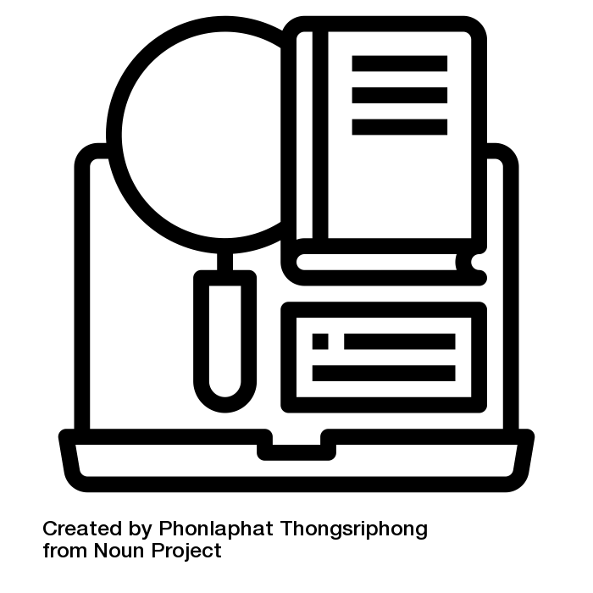

Research by Phonlaphat Thongsriphong from <a href="https://thenounproject.com/browse/icons/term/research/" target="_blank" title="Research Icons">Noun Project</a>

**Legitimate**



legal by WEBTECHOPS LLP from <a href="https://thenounproject.com/browse/icons/term/legal/" target="_blank" title="legal Icons">Noun Project</a>

**Literacy**



education by Berkah Icon from <a href="https://thenounproject.com/browse/icons/term/education/" target="_blank" title="education Icons">Noun Project</a>

**Mobile App**

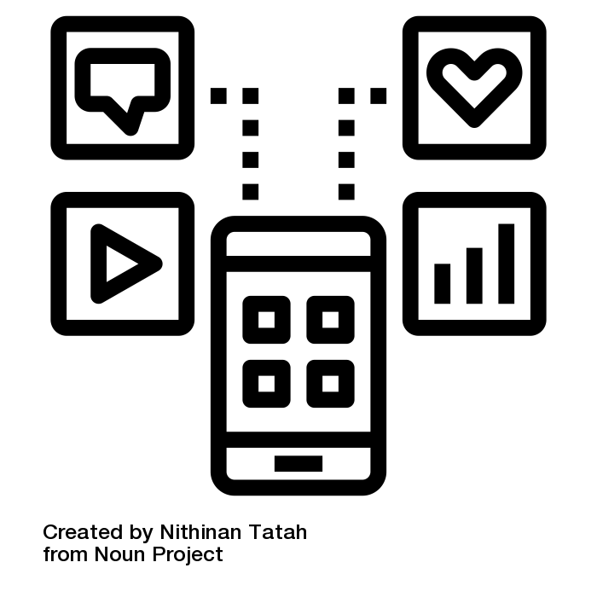

application by Nithinan Tatah from <a href="https://thenounproject.com/browse/icons/term/application/" target="_blank" title="application Icons">Noun Project</a>

**Moodle**



online education by Conley Studio from <a href="https://thenounproject.com/browse/icons/term/online-education/" target="_blank" title="online education Icons">Noun Project</a>

**Native app**

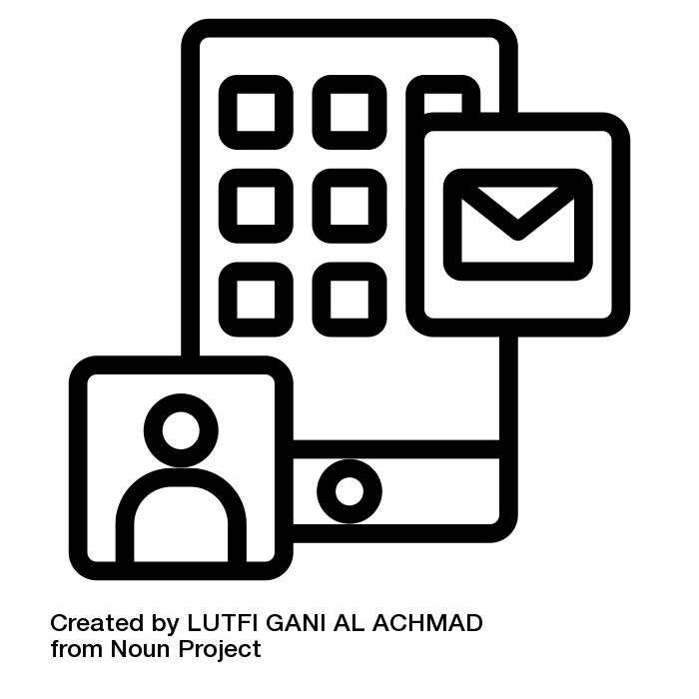

mobile app by LUTFI GANI AL ACHMAD from <a href="https://thenounproject.com/browse/icons/term/mobile-app/" target="_blank" title="mobile app Icons">Noun Project</a>

**Navigating**

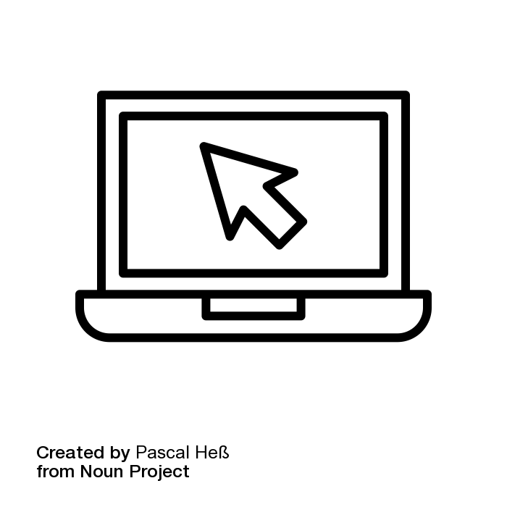

clicking in laptop by Pascal Heß from <a href="https://thenounproject.com/browse/icons/term/clicking-in-laptop/" target="_blank" title="clicking in laptop Icons">Noun Project</a>

**Net**

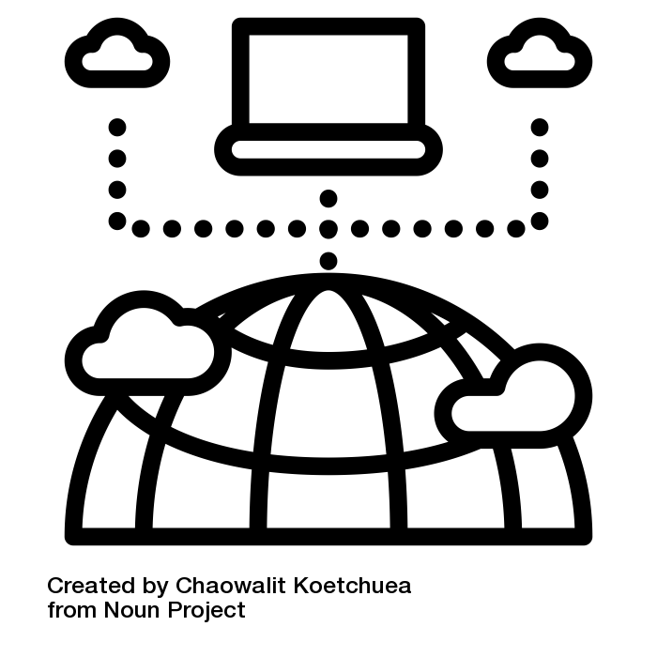

internet by Chaowalit Koetchuea from <a href="https://thenounproject.com/browse/icons/term/internet/" target="_blank" title="internet Icons">Noun Project</a>

**Netiquette or Online Etiquette**

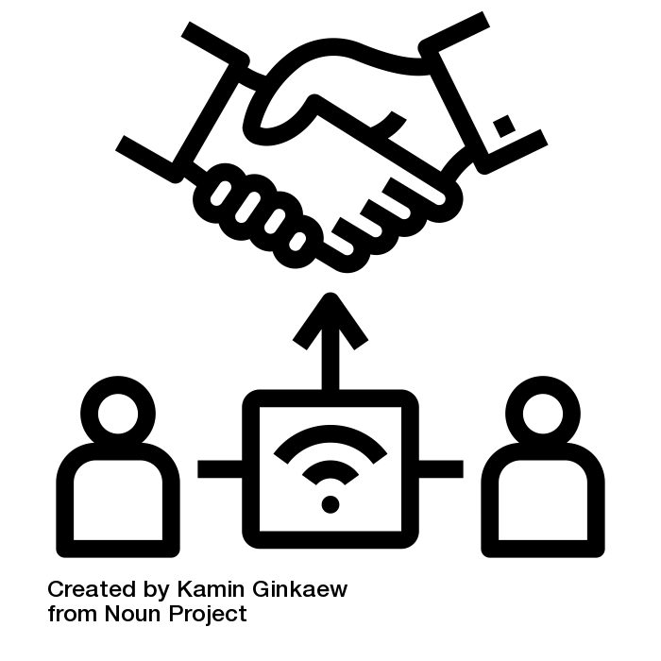

online interaction by Kamin Ginkaew from <a href="https://thenounproject.com/browse/icons/term/online-interaction/" target="_blank" title="online interaction Icons">Noun Project</a>

**Network**

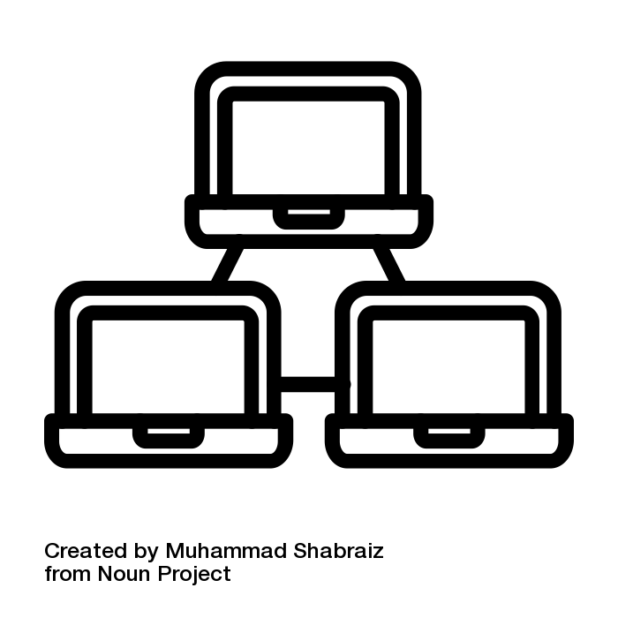

Network by Muhammad Shabraiz from <a href="https://thenounproject.com/browse/icons/term/network/" target="_blank" title="Network Icons">Noun Project</a>

**Online Health Resources**

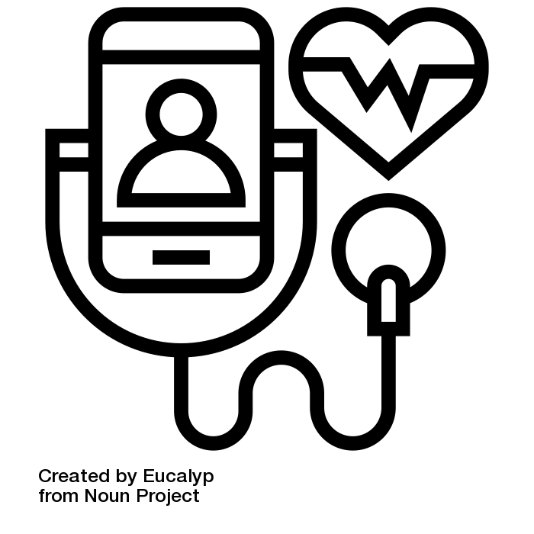

checkup by Eucalyp from <a href="https://thenounproject.com/browse/icons/term/checkup/" target="_blank" title="checkup Icons">Noun Project</a>

**Operating System**

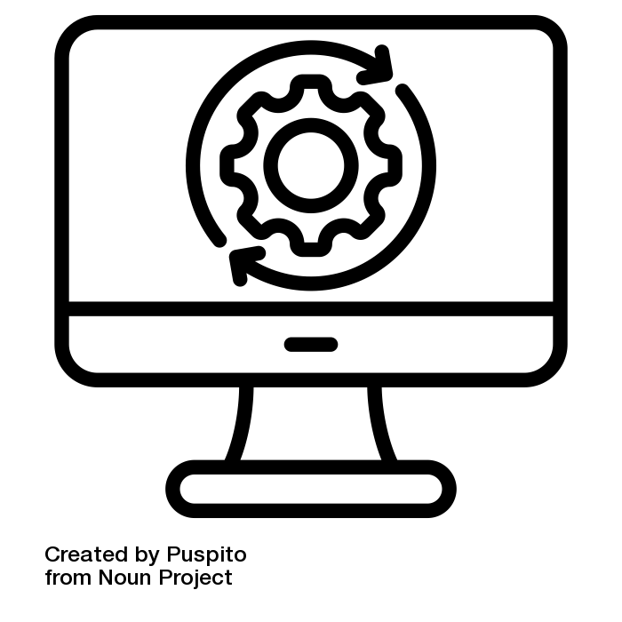

operating system by Puspito from <a href="https://thenounproject.com/browse/icons/term/operating-system/" target="_blank" title="operating system Icons">Noun Project</a>

**Passcode**

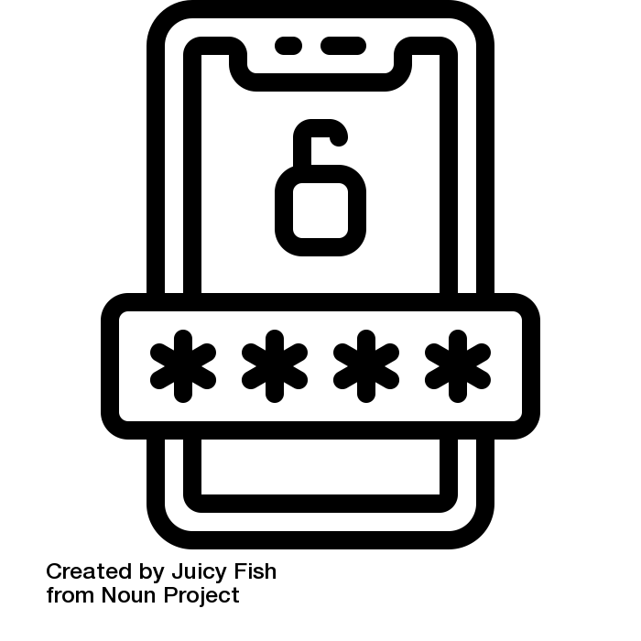

unlock passcode by Juicy Fish from <a href="https://thenounproject.com/browse/icons/term/unlock-passcode/" target="_blank" title="unlock passcode Icons">Noun Project</a>

**Password**

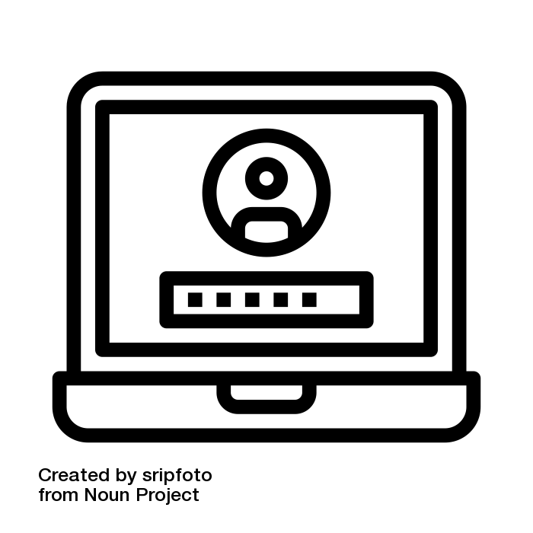

password by sripfoto from <a href="https://thenounproject.com/browse/icons/term/password/" target="_blank" title="password Icons">Noun Project</a>

**Patient Portal**

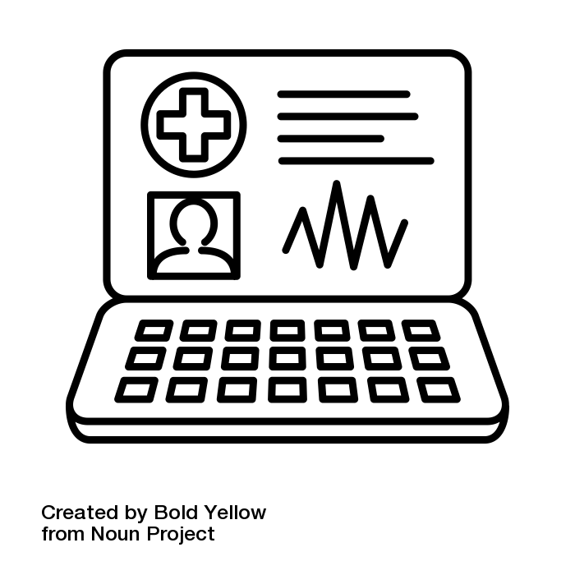

laptop ehr by Bold Yellow from <a href="https://thenounproject.com/browse/icons/term/laptop-ehr/" target="_blank" title="laptop ehr Icons">Noun Project</a>

**Personal Information**

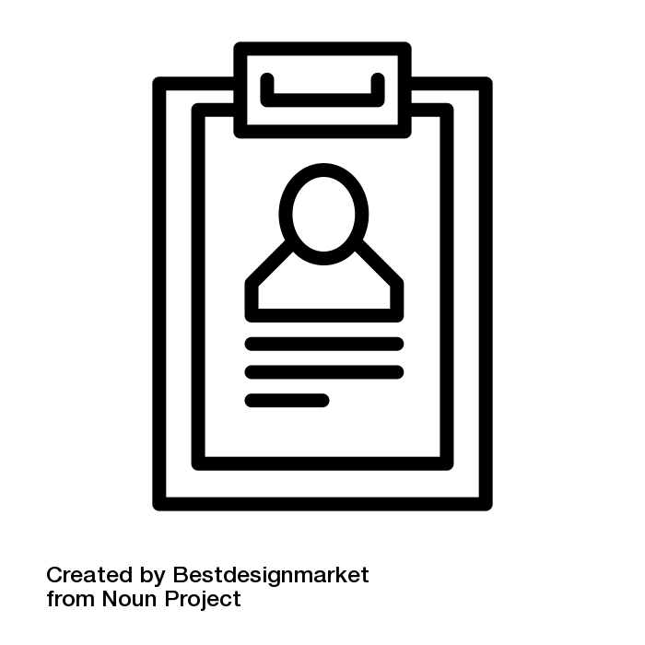

personal information by Bestdesignmarket from <a href="https://thenounproject.com/browse/icons/term/personal-information/" target="_blank" title="personal information Icons">Noun Project</a>

**Phishing**

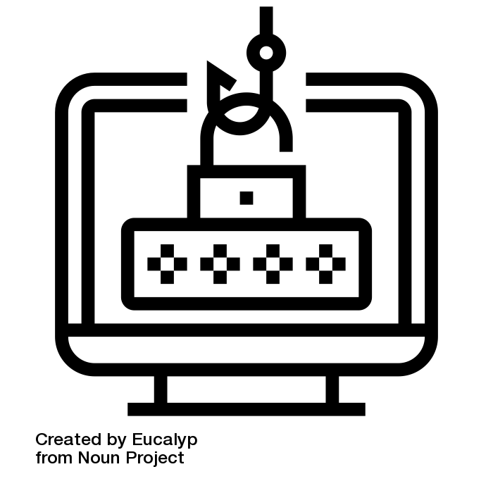

phishing by Eucalyp from <a href="https://thenounproject.com/browse/icons/term/phishing/" target="_blank" title="phishing Icons">Noun Project</a>

**Power Button**

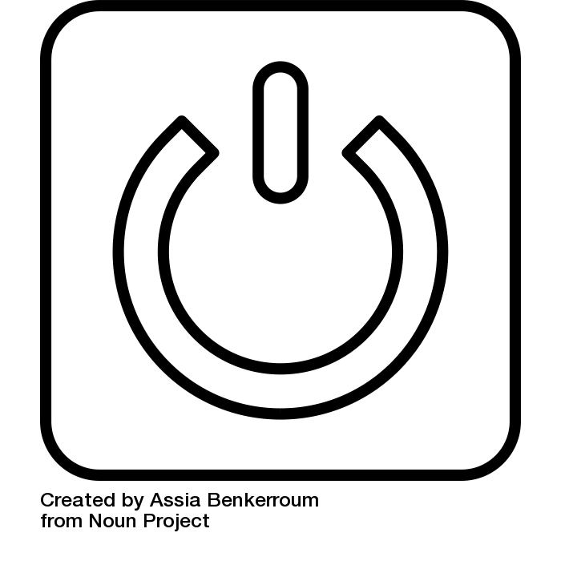

power button by Assia Benkerroum from <a href="https://thenounproject.com/browse/icons/term/power-button/" target="_blank" title="power button Icons">Noun Project</a>

**Privacy Settings**

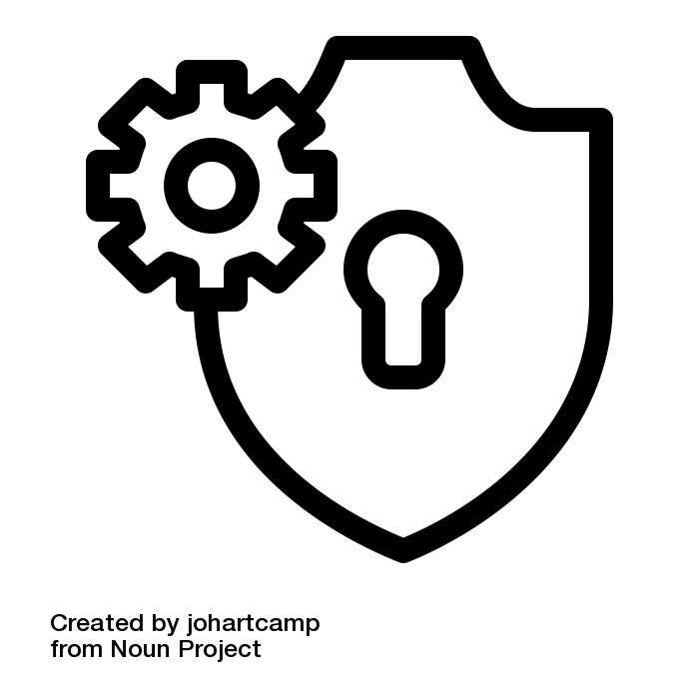

privacy settings by johartcamp from <a href="https://thenounproject.com/browse/icons/term/privacy-settings/" target="_blank" title="privacy settings Icons">Noun Project</a>

**Portal**

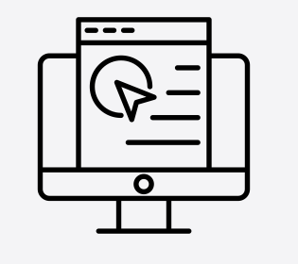

online shopping by Vectors Market from <a href="https://thenounproject.com/browse/icons/term/online-shopping/" target="_blank" title="online shopping Icons">Noun Project</a>

**Power Outlet**

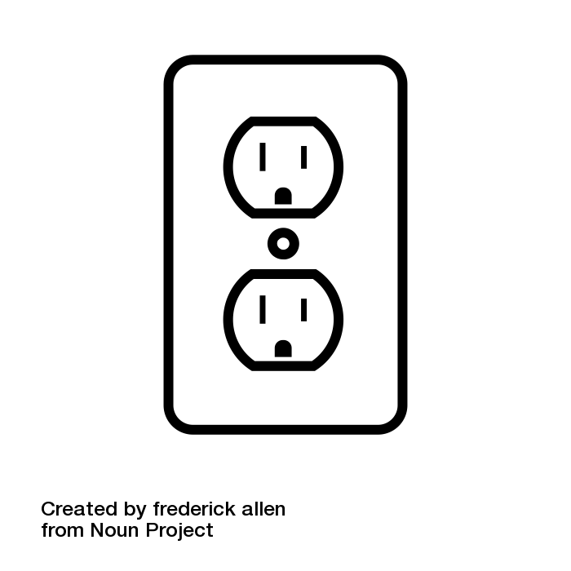

power outlet by frederick allen from <a href="https://thenounproject.com/browse/icons/term/power-outlet/" target="_blank" title="power outlet Icons">Noun Project</a>

**Process of Elimination**

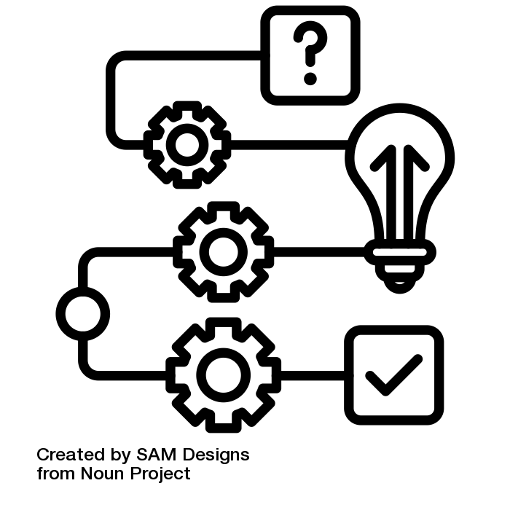

solving question by SAM Designs from <a href="https://thenounproject.com/browse/icons/term/solving-question/" target="_blank" title="solving question Icons">Noun Project</a>

**Restart**

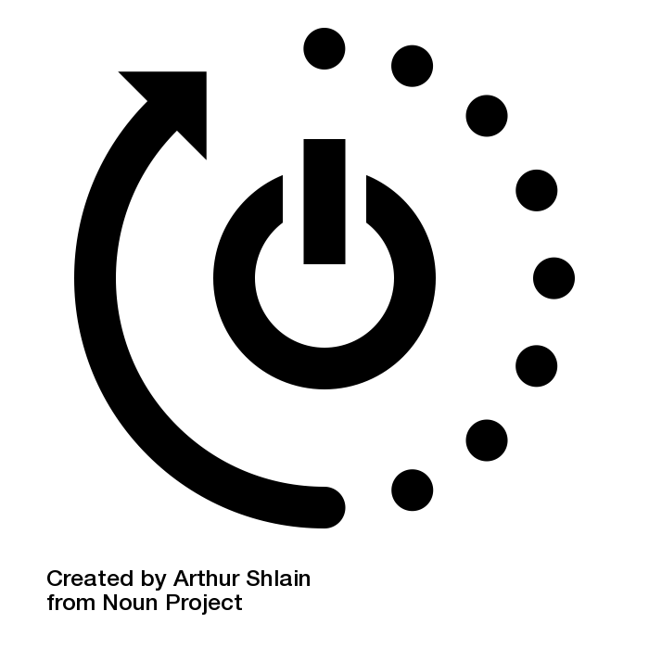

restart by Arthur Shlain from <a href="https://thenounproject.com/browse/icons/term/restart/" target="_blank" title="restart Icons">Noun Project</a>

**Search Engine**

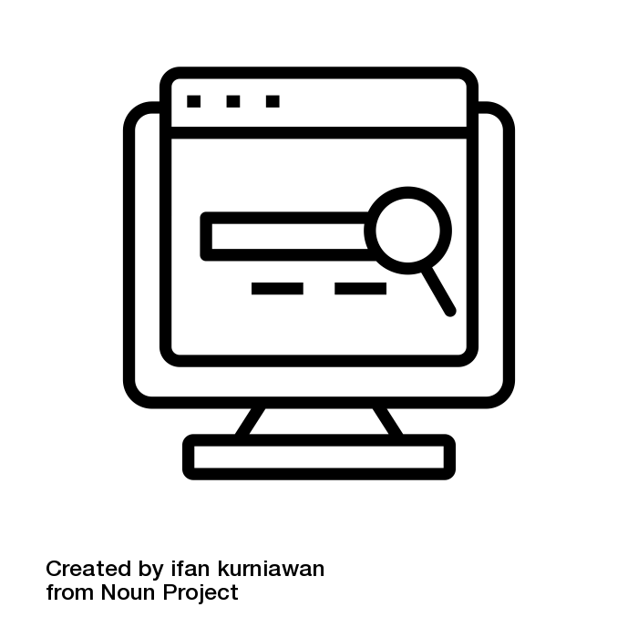

search engine by ifan kurniawan from <a href="https://thenounproject.com/browse/icons/term/search-engine/" target="_blank" title="search engine Icons">Noun Project</a>

**Self-Advocacy**

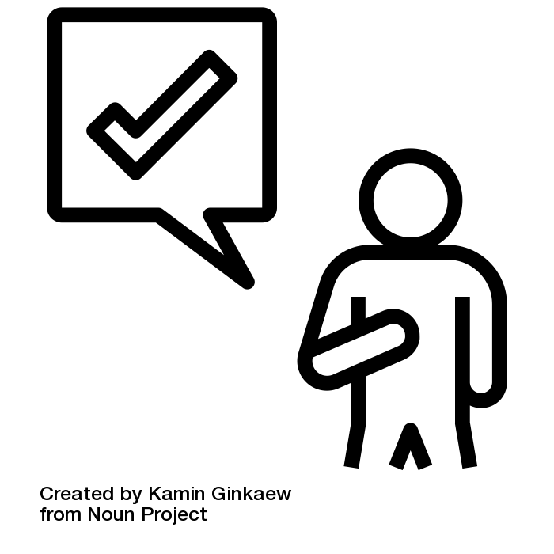

self confident by Kamin Ginkaew from <a href="https://thenounproject.com/browse/icons/term/self-confident/" target="_blank" title="self confident Icons">Noun Project</a>

**Self-Determination**

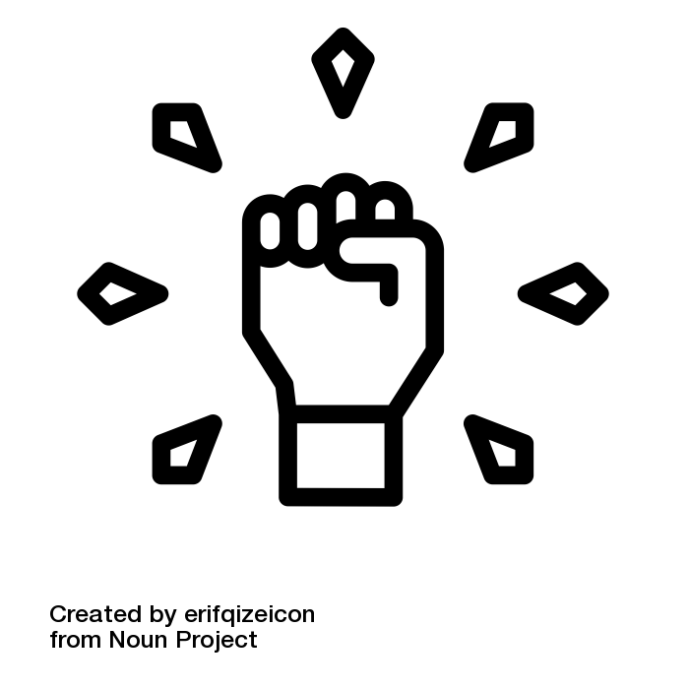

autonomy by erifqizeicon from <a href="https://thenounproject.com/browse/icons/term/autonomy/" target="_blank" title="autonomy Icons">Noun Project</a>

**Settings**

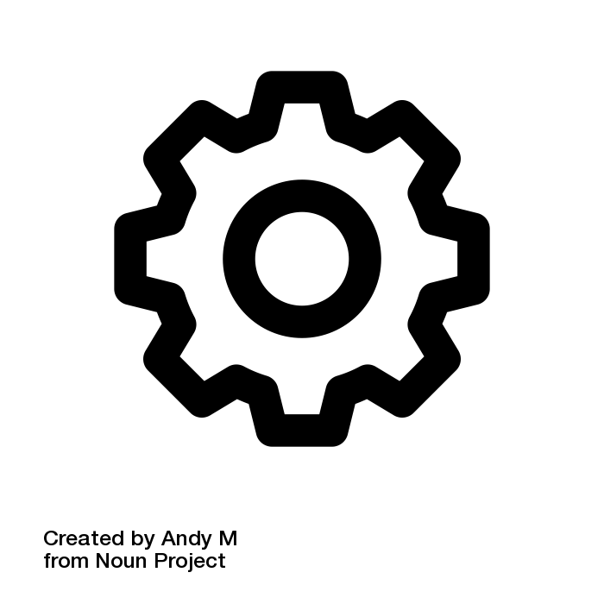

Settings by Andy M from <a href="https://thenounproject.com/browse/icons/term/settings/" target="_blank" title="Settings Icons">Noun Project</a>

**Software**

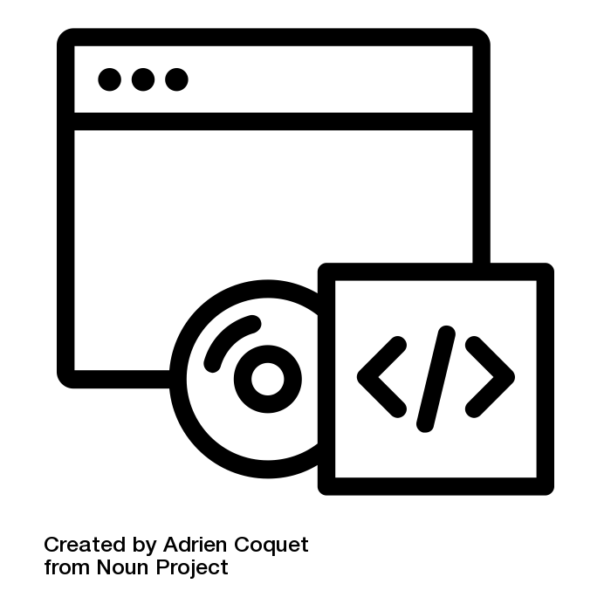

Software by Adrien Coquet from <a href="https://thenounproject.com/browse/icons/term/software/" target="_blank" title="Software Icons">Noun Project</a>

**Software Update**

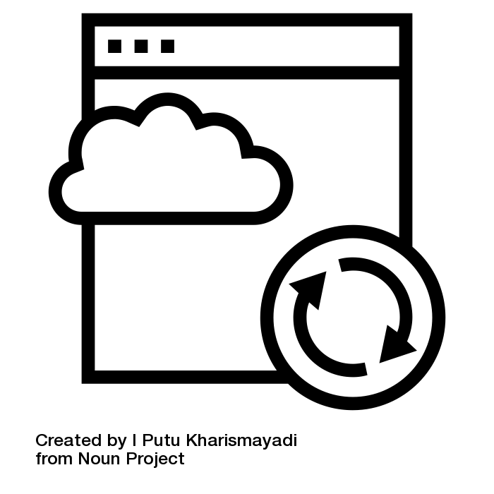

online update by I Putu Kharismayadi from <a href="https://thenounproject.com/browse/icons/term/online-update/" target="_blank" title="online update Icons">Noun Project</a>

**Supported Decision Making**

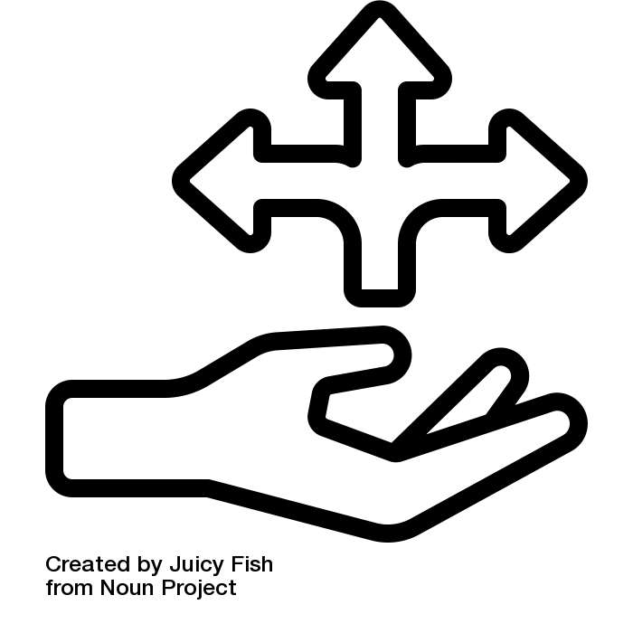hand giving guidance by Juicy Fish from <a href="https://thenounproject.com/browse/icons/term/hand-giving-guidance/" target="_blank" title="hand giving guidance Icons">Noun Project</a>

**Surge Protector**

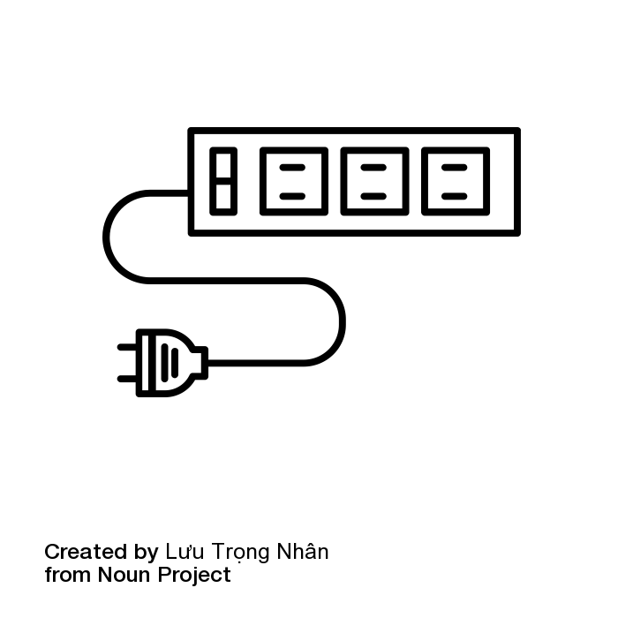

3-Socket Surge Protector by Lưu Trọng Nhân from <a href="https://thenounproject.com/browse/icons/term/3-socket-surge-protector/" target="_blank" title="3-Socket Surge Protector Icons">Noun Project</a>

**Sleep Mode**

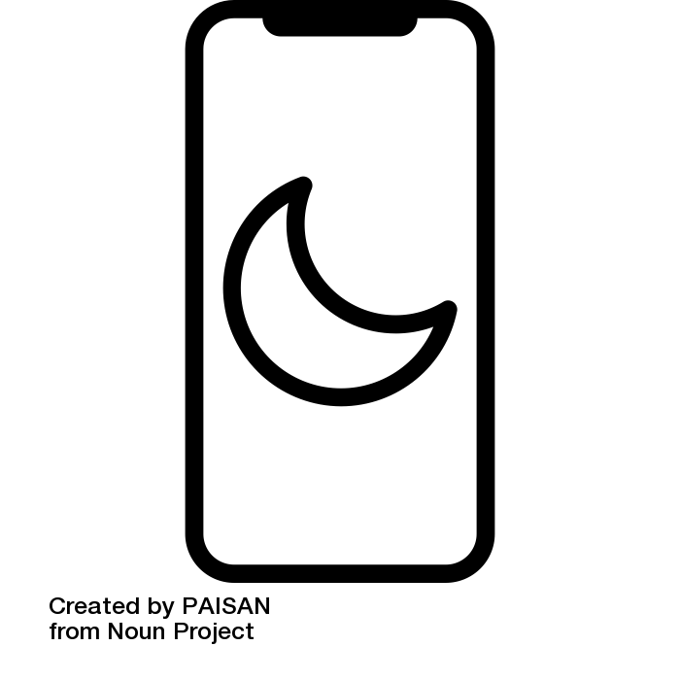

Sleep Mode by PAISAN from <a href="https://thenounproject.com/browse/icons/term/sleep-mode/" target="_blank" title="Sleep Mode Icons">Noun Project</a>

**Stylus**

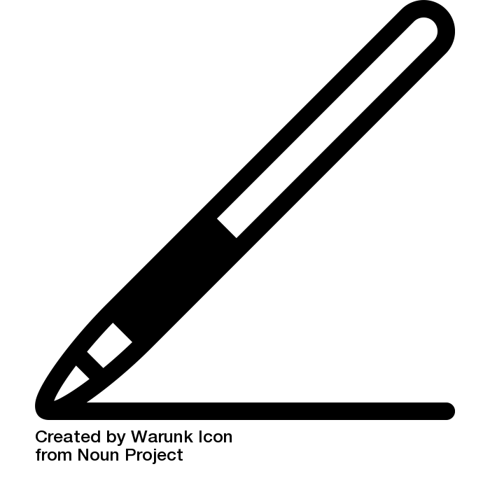

stylus by Warunk Icon from <a href="https://thenounproject.com/browse/icons/term/stylus/" target="_blank" title="stylus Icons">Noun Project</a>

**Swiping Gestures**

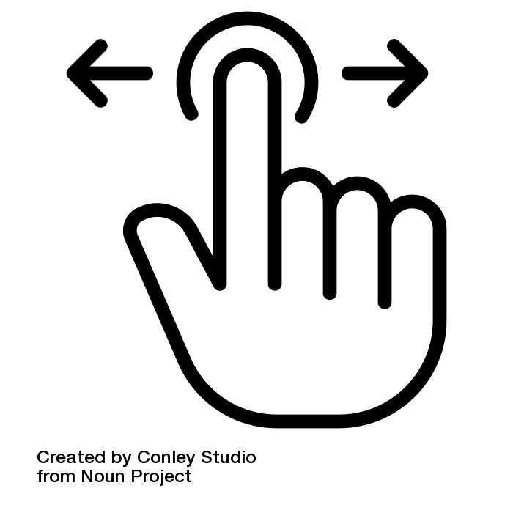

swiping by Conley Studio from <a href="https://thenounproject.com/browse/icons/term/swiping/" target="_blank" title="swiping Icons">Noun Project</a>

**TeleHealth**

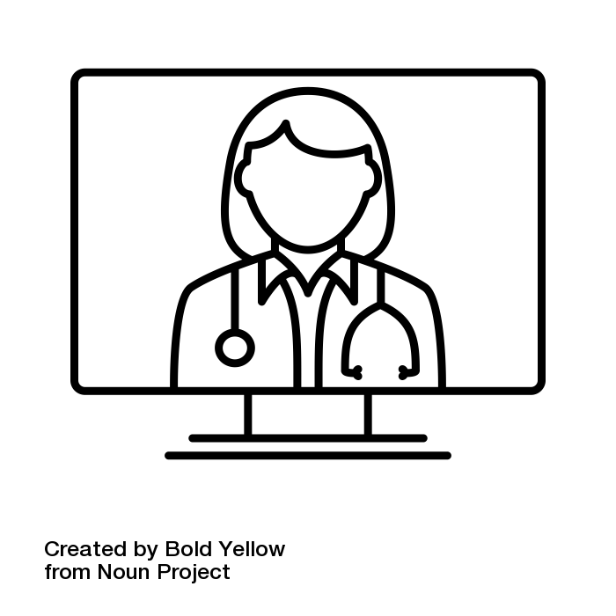

Telehealth by Bold Yellow from <a href="https://thenounproject.com/browse/icons/term/telehealth/" target="_blank" title="Telehealth Icons">Noun Project</a>

**Two-Factor Authentication**

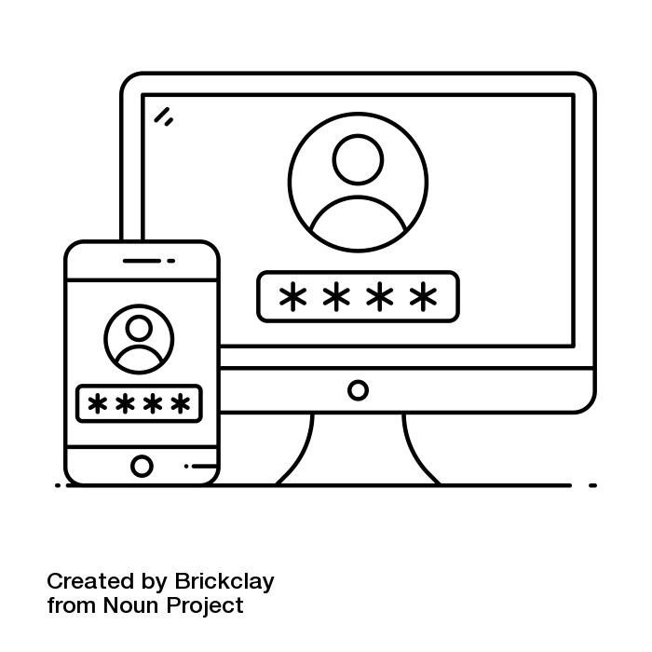

two step verification by Brickclay from <a href="https://thenounproject.com/browse/icons/term/two-step-verification/" target="_blank" title="two step verification Icons">Noun Project</a>

**Username**

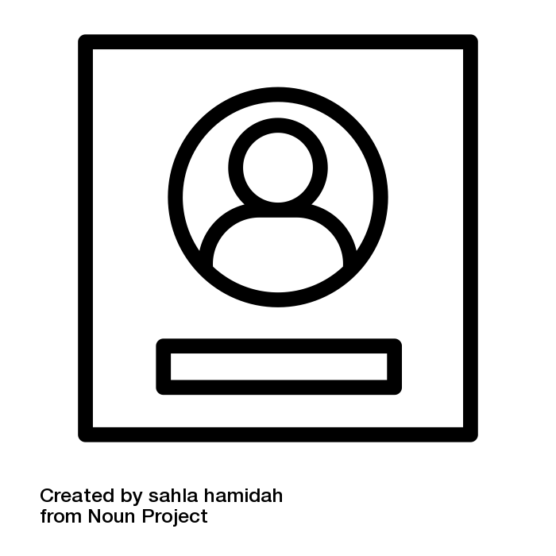

User by sahla hamidah from <a href="https://thenounproject.com/browse/icons/term/user/" target="_blank" title="User Icons">Noun Project</a>

**Virus**

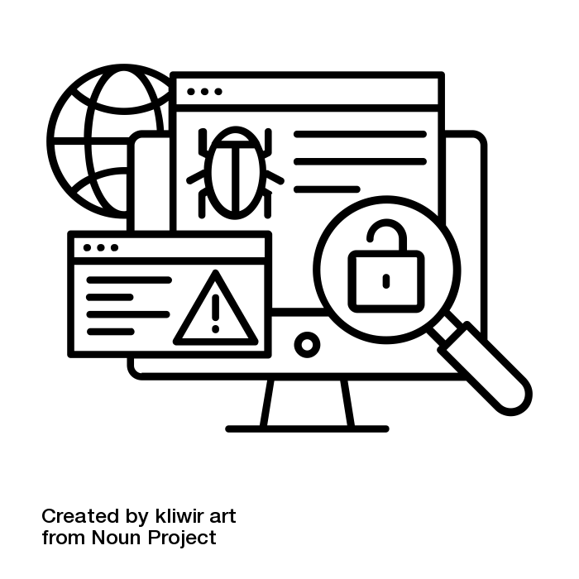

Computer Virus by kliwir art from <a href="https://thenounproject.com/browse/icons/term/computer-virus/" target="_blank" title="Computer Virus Icons">Noun Project</a>

**VPN**

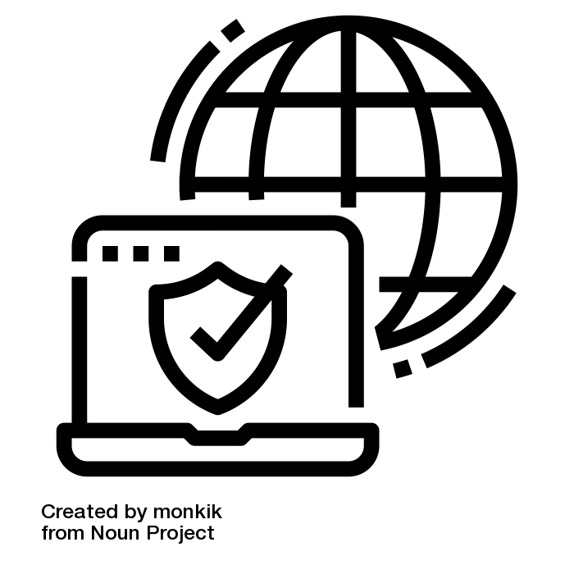

VPN by monkik from <a href="https://thenounproject.com/browse/icons/term/vpn/" target="_blank" title="VPN Icons">Noun Project</a>

**Wearable Device**

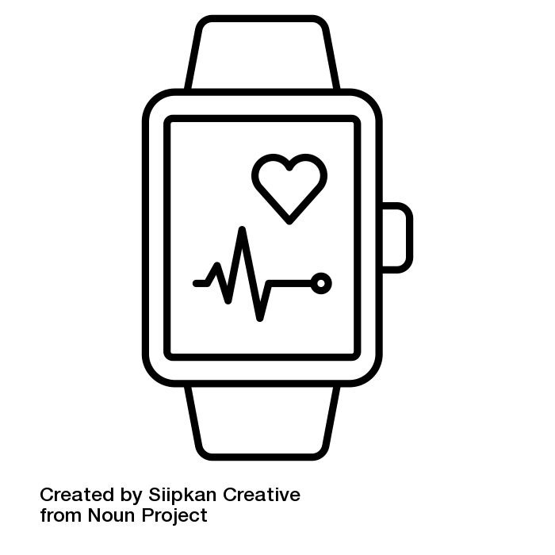

Wearable device by Siipkan Creative from <a href="https://thenounproject.com/browse/icons/term/wearable-device/" target="_blank" title="Wearable device Icons">Noun Project</a>

**Web-Based App**

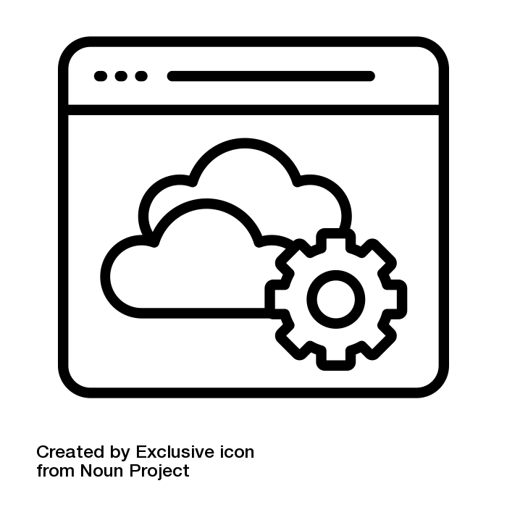

web app by Exclusive icon from <a href="https://thenounproject.com/browse/icons/term/web-app/" target="_blank" title="web app Icons">Noun Project</a>

**Wi-Fi**

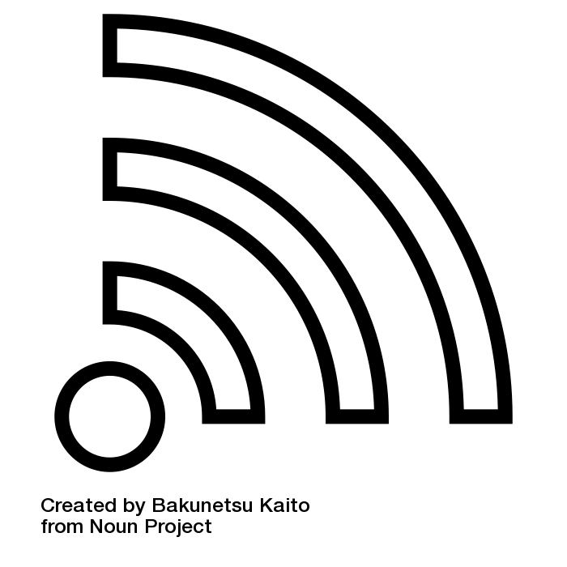

wi-fi by Bakunetsu Kaito from <a href="https://thenounproject.com/browse/icons/term/wi-fi/" target="_blank" title="wi-fi Icons">Noun Project</a>

**Wireless Router**

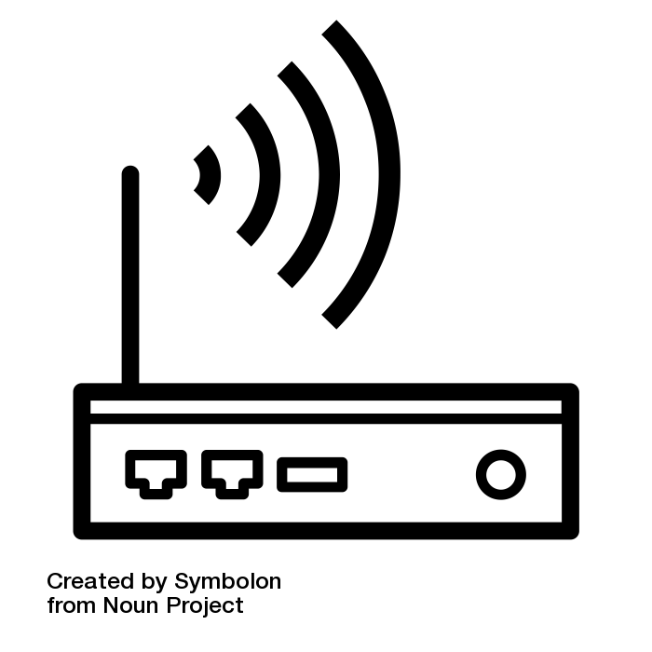

Wireless Router by Symbolon from <a href="https://thenounproject.com/browse/icons/term/wireless-router/" target="_blank" title="Wireless Router Icons">Noun Project</a>